**SIKSHA 'O' ANUSANDHAN**

**(DEEMED TO BE UNIVERSITY)**



**Department of Electronics & Communication Engineering,**

**Institute of Technical Education and Research**

# CIRCUIT THEORY



**(EET2111)**



**DESIGN PROJECT**



SUBMITTED BY

|  |  |  |  |  |  |
| --- | --- | --- | --- | --- | --- |
| NAME: |  | Anirban Chatterjee | | |  |
|  | | |
| REGISTRATION NO.: | **2241003014** | | | | |
| BRANCH – SECTION: |  | | **ECE-2241035** |  | |
|  |
| SEMESTER: | **4th Semester** | | | | |

**DECLARATION**

I certify that

1. The work contained in this report is original and has been done by me.
2. I have followed the guidelines provided by the Institute in preparing the report.
3. I have conformed to the norms and guidelines given in the Ethical Code of Conduct of the Institute.
4. I have tried to complete the work with minimum possible cost.
5. Whenever I have used materials (data, theoretical analysis, figures, and text) from other sources, I have given due credit to them by citing them in the text of the report and giving their details in the references.

**Submitted By:**

**Name:** Anirban Chatterjee

**Regd No:** 2241003014

**Branch:** ECE

**Section:** 2241035

**____________________**

**Signature**

## 1. PROBLEM STATEMENT

Design a 2nd order active Band Pass Filter (BPF) which will pass the signals of frequency range from 1KHz to 5KHz**.**

## 2. CIRCUIT OPERATING CONSTRAINTS

The design of a 2nd order active Band pass Filter (BPF) to pass signals within the frequency range of 1KHz to 5KHz involves considering several circuit operating constraints.

* The Active Band Pass Filter (BPF) pass the signals within the frequency range of 1KHz to 5Khz.
* One of the primary constraints is the selection of appropriate operational amplifier (op-amp) circuits. The chosen op-amp should possess characteristics such as high gain, low input and output impedance, and sufficient bandwidth to handle the desired frequency range. Also, the op-amp must be able to operate within the specified power supply voltage limits. Here, we have to used 741 IC .
* The selection of suitable passive components, including resistors and capacitors, that determine the filter's cut-off frequencies and attenuation characteristics. These components must have values within the range that satisfies the desired frequency range while considering the tolerance and availability of commercially available values. Practically, we have used resistor of 4.2Kohm for LPF and

A variable in a range of (0-20)Kohm for HPF due to unavailability of this resistor.

* The selection of the physical implementation, such as board space, component size, and cost, should be taken into account. Practical considerations and limitations in terms of available resources and manufacturing constraints should be considered during the design process.

**3. THEORETICAL BACKGROUND.**

### a) INTRODUCTION

The band pass filter is formed by the low pass and high pass filters with a cascading connection. The name itself indicates that it will pass a particular band of frequencies and eliminate other frequencies.

#### 1. OPAMP

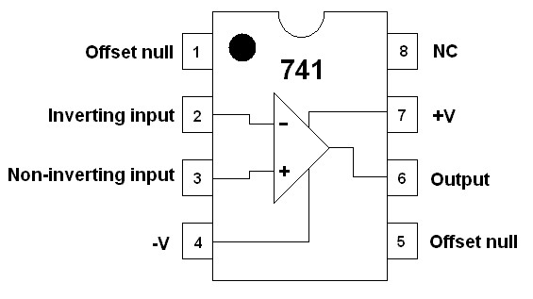

The 741 Op Amp IC is a monolithic integrated circuit, comprising of a general-purpose Operational Amplifier. The number 741 indicates that this operational amplifier IC has 7 functional pins, 4 pins capable of taking input and 1 output pin.

#### 2. RESISTOR

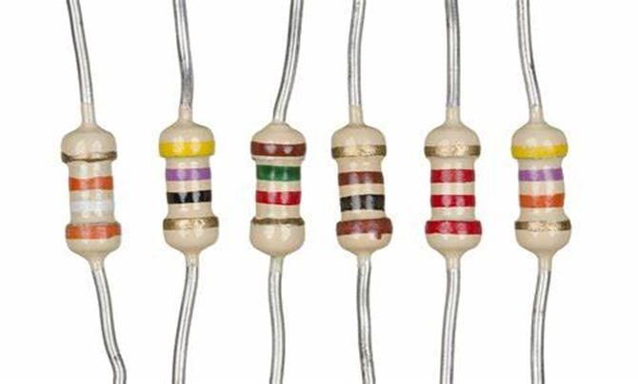

A resistor is a passive two-terminal electrical component that implements electrical resistance as a circuit element. In electronic circuits, resistors are used to reduce current flow, adjust signal levels, to divide voltages, bias active elements, and terminate transmission lines, among other uses. High power resistors that can dissipate many watts of electrical power as heat may be used as part of motor controls, in power distribution systems, or as test loads for generators.

#### 3. CAPACITORS

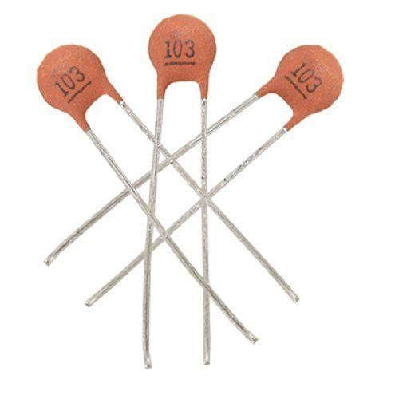

A capacitor is a device that stores electrical energy in an electric field by virtue of accumulating electric charges on two close surfaces insulated from each other. It is a passive electronic component with two terminals. The effect of a capacitor is known as capacitance. While some capacitance capacitor is a component designed to add capacitance to a circuit.

**b) BLOCK DIAGRAM**

Amplify

High Pass Filter

Low pass Filter

Vout

##### c)MATHEMATICAL MODELLING / ANALYSIS

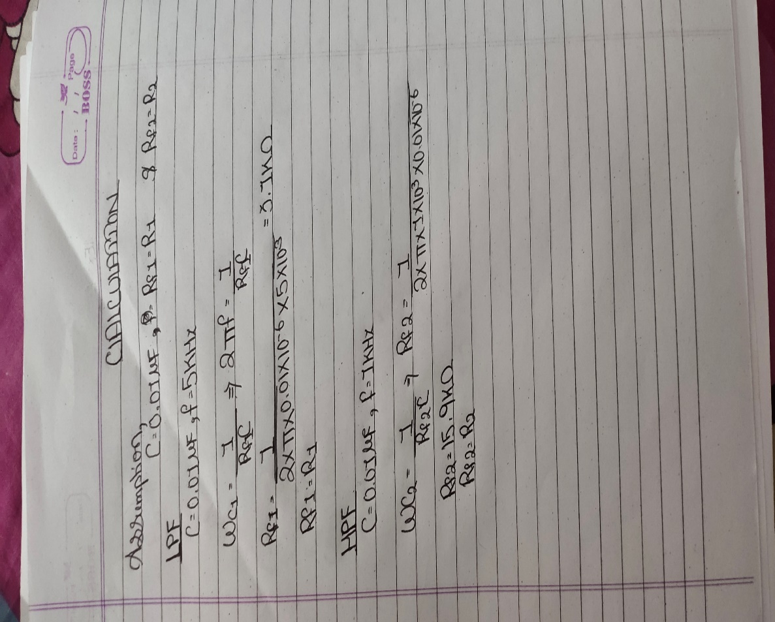

##### d) WORKING

* 1. A low-pass filter (LPF) and a high-pass filter (HPF) are combined to form a band pass filter. These filters are cascade t so that they permit exclusively only some specific frequencies, called the pass band. This implies that all other frequencies beyond this range get attenuated.
  2. These two cut-off frequencies are predetermined based on the component values used in the circuit. The band pass filter allows the frequencies between these two cut-off frequencies and are attenuated or rejected other frequencies.
  3. The LPF is for high cut off frequency which doesn’t allow high frequency to pass through it and HPF is for low cut off frequency which doesn’t allow low frequency to pass through it.
  4. The final output from the high pass filter amplified by using an operational amplifier (op-amp) to improve the voltage gain.

### Characteristics of Band Pass Filter

### 

This filter allows the frequencies of a signal in a particular range i.e., above and below the cut-off frequency. So, it has two stop band and one pass band. The pass band represents ranges between the two cut-off frequencies. While the two stop bands represents the frequencies below and above the cut-off frequencies of low pass and high pass filter circuits that are rejected.

The main characteristic of the band pass filter is, a bandpass filter in a receiver allows signals within a certain range of frequencies to be heard or decoded while blocking signals at undesired frequencies. A bandpass filter also improves a receiver's signal-to-noise ratio

### Frequency Response of Band Pass Filter

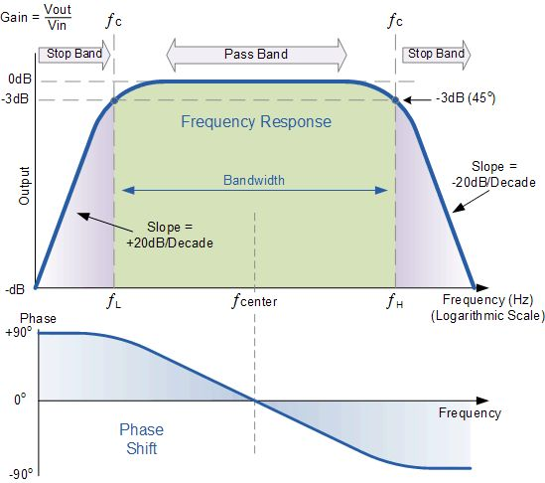

The frequency response is drawn between frequency vs gain. In practice, the switching mechanism of the capacitor changes the output characteristics of high pass and low pass filters and are not similar to the ideal filter. The pass band gain of this filter should be equal to the gain of the low pass and high pass.

**CIRCUIT DESIGN**

The design of an active band pass filter using high-pass and low-pass filters with an operational amplifier (op-amp) can be divided into several blocks or stages, each with its specific function. Here's an overview of the different blocks involved:

1. **High-Pass Filter**: This block is designed to attenuate or block frequencies below the centre frequency (f0) of the band pass filter. It typically consists of passive components (such as resistors and capacitors) or active components (such as op-amps) arranged in a configuration that allows higher frequencies to pass through while attenuating lower frequencies.
2. **Low-Pass Filter**: This block is designed to attenuate or block frequencies above the centre frequency (f0) of the band pass filter. Similar to the high pass filter, it can be implemented using passive components or active components in a configuration that allows lower frequencies to pass through whileattenuating higher frequencies.
3. **Operational Amplifier (Op-Amp):** The op-amp is used as an active element in the design, serving as a voltage amplifier and providing gain to the filtered signal. It is typically used to combine the outputs of the high-pass provide the final output of the band pass filter. The op-amp may also required additional passive components, such as resistors and capacitors, to set its gain, bandwidth, and stability.

## 4. CIRCUIT DIAGRAM

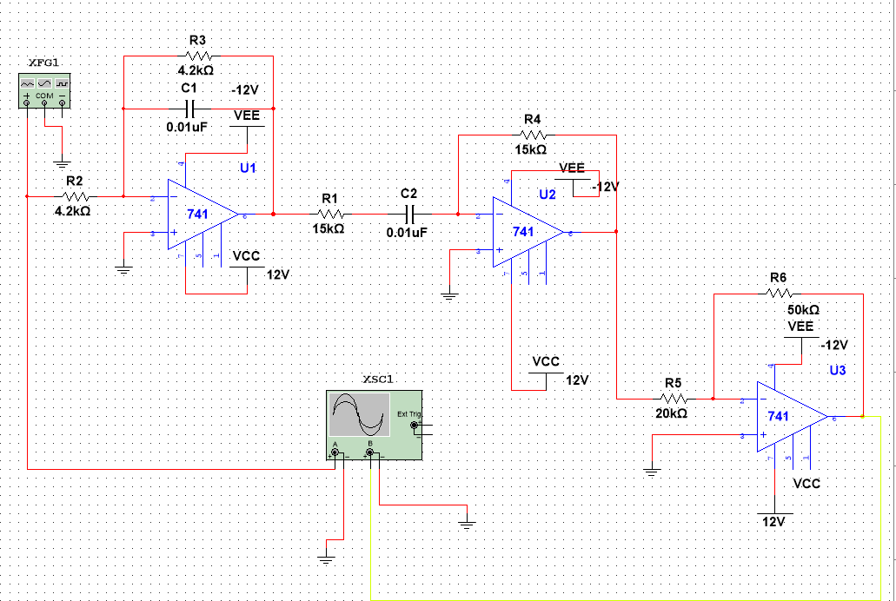

## 5. DESIGN SPECIFICATION

|  |  |  |  |  |
| --- | --- | --- | --- | --- |
| **Sl. o.** | **Component Name** | **Specification** | **No. of units** | **Price Per**  **Unit** |
| 1. | OPAMP | µA741 | 3 | Rs. 20 |
| 2. | Resistor | 20K(variable), 4.2K, 10K,47K,1K,15K | 2, 2, 2,1,7,2 | Rs. 2 and  7 (variable R) |
| 3. | Capacitor | 0.01uF | 3 | Rs. 2 |
| 4. | Connecting Wires | 23SWG | As per requirement | Rs. 10 |
| 5. | TOTAL |  |  | Rs. 120 |

## 6.HARDWARE SETUP

**a) Breadboard Implementation**

**b) Complete Setup** 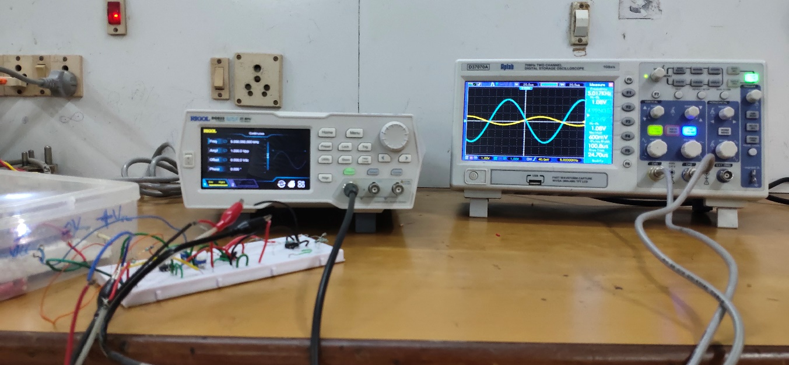

## 7. RESULT

### SIMULATION RESULT

1. Before 1Khz **(10 hz)**

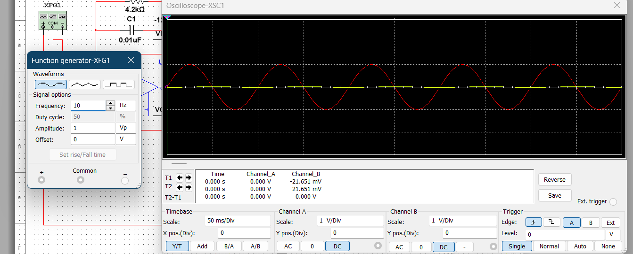

1. At 1KHz

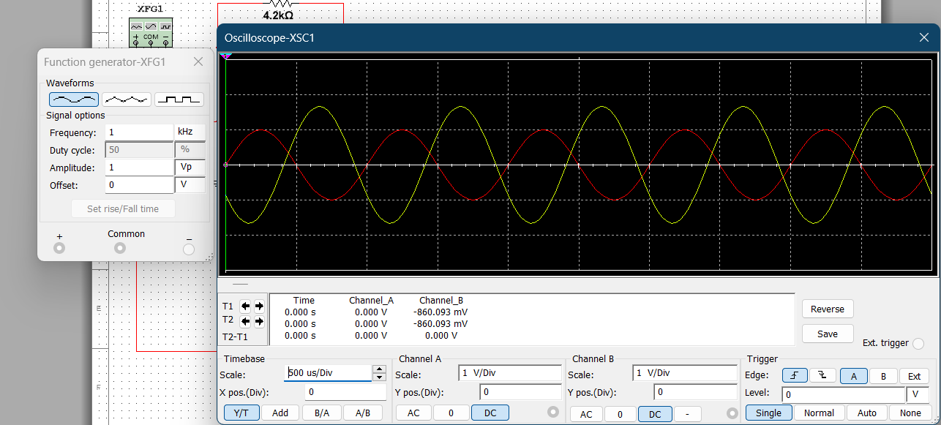

C)At 5Khz

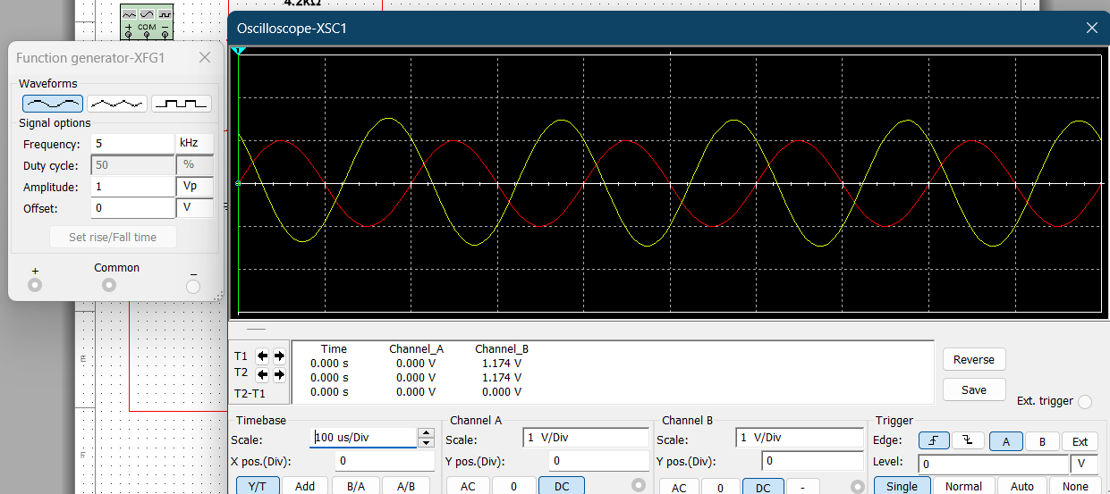

**GRAPH :**

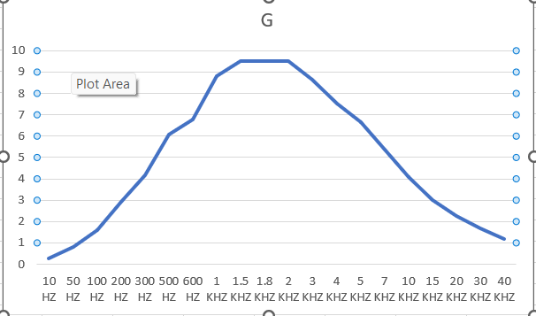

### HARDWARE RESULT

A)Before 1KHz (800 hz)

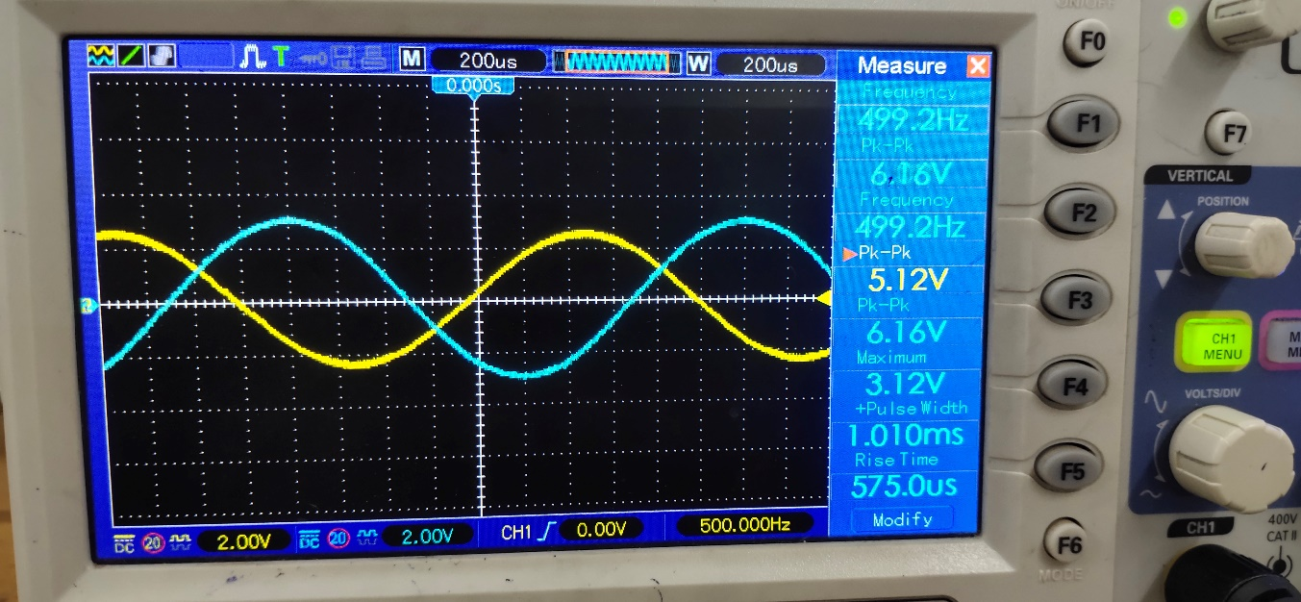

1. At 1KHz

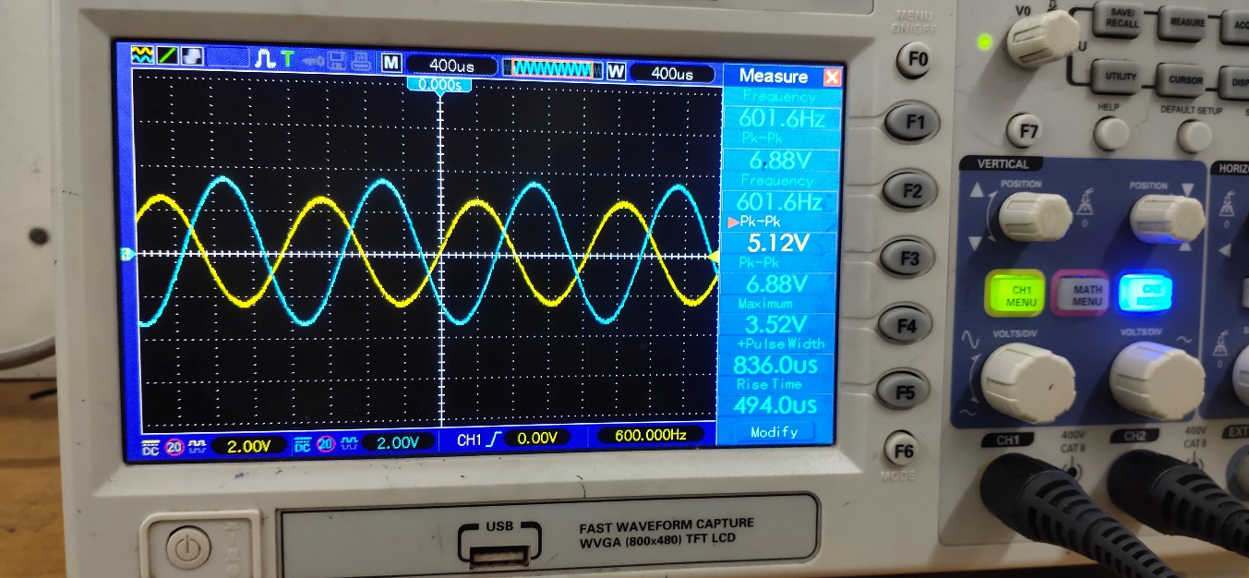

1. At 5KHz

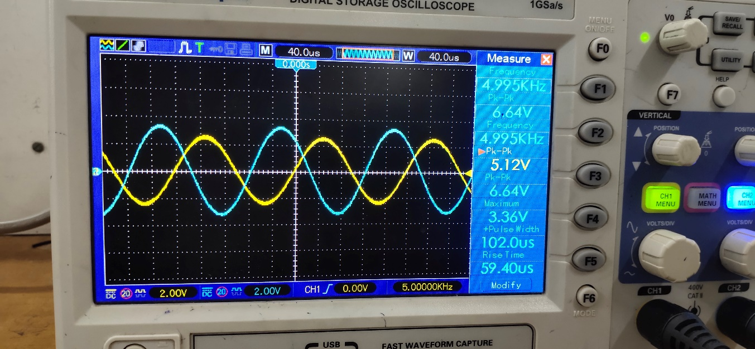

## 8. COMMENTS

In conclusion, it has been successfully designed to allows signals within the frequency range of 1KHz to 5KHz using a 2nd order active Band Pass Filter (BPF). The main goal of this project was to create a filter capable of passing signals within a certain frequency range while rejecting all other frequencies to pass through it.

An active filter design was used to do this since it can offer high gain and fine frequency control. The steeper roll-off characteristics of the 2nd order filter design improved the filter's ability to pass the desired frequency range.

In order to reach the intended cut-off frequencies, the design procedure involved choosing the right operational amplifier (op-amp) circuits and figuring out component values. To confirm the filter's effectiveness in passing frequencies between 1KHz and 5KHz while keeping appropriate passband and stopband characteristics, numerous calculations and simulations were performed. low through with little to no change. After successful modelling and verification, a hardware prototype was used to create and test the planned 2nd order active BPF. The outcomes showed that the filter successfully reduced signals within the designated frequency range to an acceptable level by suppressing them.

The successful conclusion of this study makes a contribution to the field of signal processing by offering an effective technique for attenuating undesirable noises within a particular frequency band. When the elimination of particular frequency components is necessary, the developed 2nd order active BPF can be used in a variety of industries, including as audio processing, telecommunications, and instrumentation. As a whole, this effort adds to the development of signal processing techniques and lays the groundwork for future advancements in active filter design.

## 9. REFERENCE

* Fundamentals of Electric Circuits 7th Edition by Charles K. Alexander and Matthew N. O. Sadiku
* Operational Amplifiers & Linear ICs by David A. Bell
* https://www.electronicshub.org/active-band-pass-filter/

**10. Data Sheet**